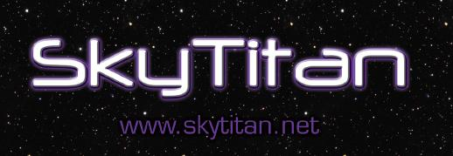
Advanced STEM Education
Professional Development

SkyTitan provides on-site Professional Development workshops that deliver advanced training for the educational resources that we provide. Participants will receive training with software, probe ware, standards-based activities, and will connect to our remote telescopes in Australia to become familiar with the telescope systems that they will be using in their classrooms. Not only will teachers receive in-depth training with these resources, but they will also keep the software applications and probe ware. In addition, workshop participants will receive 12 - 18 hours of telescope time on SkyTitan telescopes located in the US and Australia.

INNOVATIVE APPROACH
SkyTitan resources deliver innovative educational opportunities by incorporating:
- Technology-centered resources
- Interdisciplinary content
- Rigorous and engaging activities
- Real-life applications of math and science skills
- Access to scientific grade equipment
- Collaboration with peers and professionals
- Research opportunities
- Professional Learning Communities

TECHNOLOGY
- Remotely controlled telescopes in multiple global locations
- Web Based eLearning classrooms
- Videoconferencing
- Probe-ware
- Simulation software
- Image processing software
- Scripting and planning software
- Robotic systems control

STANDARDS BASED
SkyTitan resources are aligned to relevant educational standards. The effective adoption and integration of materials occurs when they are aligned with the standards that drive curriculum. We have aligned our materials with:
- Current National Math and Science standards
- Common Core standards
- Alignment with State standards as needed

CLASSROOM MATERIALS
Each participant will be provided a copy of the software and probe-ware to take with them for use in their classroom.
- Software Bisque – The Sky (simulation and telescope control software)
- Software Bisque – CCDSoft (image processing software)
- CCDWare – CCD Navigator (observational scripting and planning software)
- Pasco Scientific – Pasport sound, light, and temperature probe with computer interface
- SkyTitan – PARSEC subscription with additional telescope time
- SkyTitan – Collaboration suite membership

WORKSHOP FORMAT
- Multi-district or statewide workshops will be facilitated at a regional location that can best accommodate travel for all attendees. Single district workshops will be facilitated at an on-site location of their choice.
- Participation is limited to 12 attendees per workshop. The breakdown will be 4 Elementary, 4 Middle School/Jr. High, and 4 High School.
- Teachers will be required to bring a laptop on which they have administrative rights so that they can install the software.
- Workshops will last a total of 5 days (M-F) and may include evening sessions for lab activities. (see the schedule at the end of this document)
- SkyTitan will endeavor to have workshop participation approved for professional development and recertification credit with their certifying agencies.

Professional Learning Community
Participants will be assigned to teams within their grade level. Ideally this will be two teams comprised of two members each. SkyTitan’s collaboration suite will facilitate an on-going Professional Learning Community (PLC) for these two-man teams. The purpose for these PLCs is to:
- Provide continued training and maintain skills
- Facilitate professional collaboration for:
  - Sharing results and ideas
  - Pedagogy development
  - Identify best-practices
- Provide for professional accountability
Collaboration will also be facilitated between the various grade levels so as to establish proper vertical alignment and progression (sequence) of academic content.

EXTENDED OPPORTUNITIES

SkyTitan has a number of professional associations. One of these is with the Las Cumbres Observatory Global Telescope Network (LCOGT). This is a network of professional grade telescopes that are located around the globe. Participants that complete SkyTitan PD workshops will acquire the necessary skills and experience to be eligible to utilize these high-end astronomical systems. These instruments are research grade and enable students to advance into educational opportunities at a professional level.

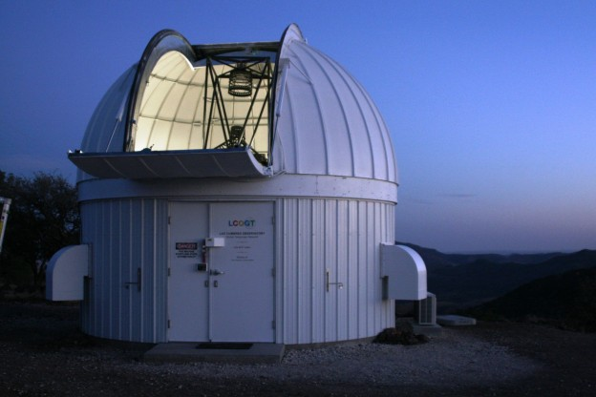

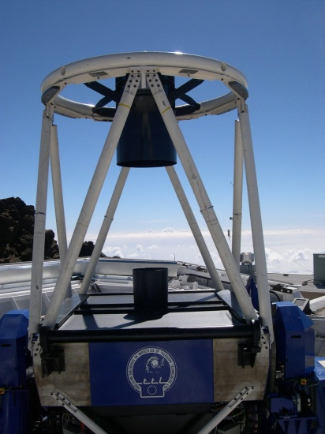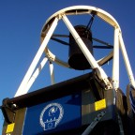
2012-2013 SCHEDULE
SkyTitan workshops include live observing sessions. Many activities are centered on the observation of celestial objects that are considered deep space objects. It is therefore necessary to facilitate workshops on nights with less lunar illumination. The following dates represent the optimum weeks of the month for darker skies.
2012
NOVEMBER
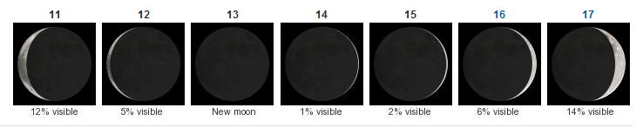 11th - 17th
DECEMBER
9th - 15th 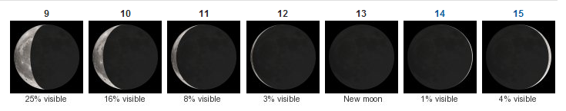

2013
JANUARY
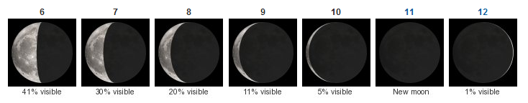 6th - 12th
FEBRUARY
3rd - 9th 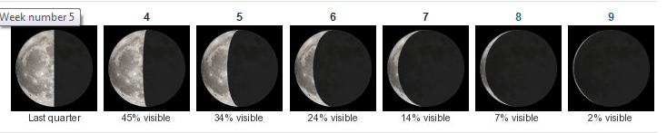

MARCH
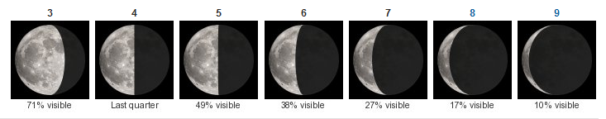 3rd - 9th
APRIL
7th - 13th 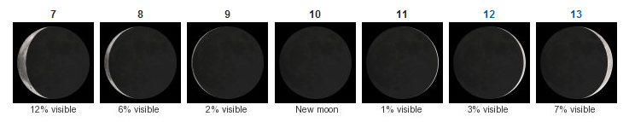
MAY
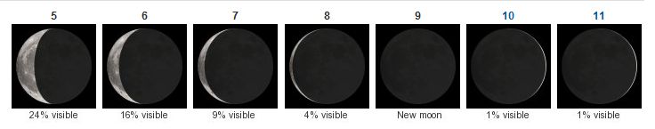 5th - 11th
JUNE
2nd - 8th 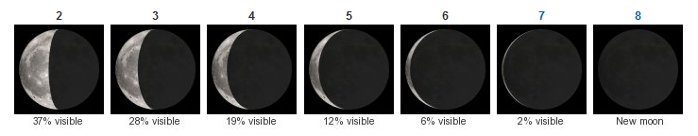
JULY
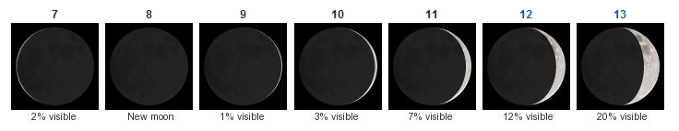 7th - 13th
AUGUST
4th - 10th 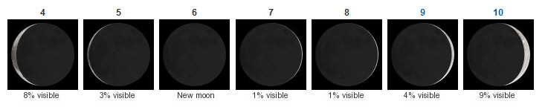
SEPTEMBER
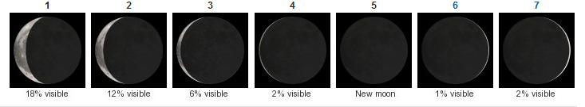 1st - 7th
OCTOBER
9/29 - 5th 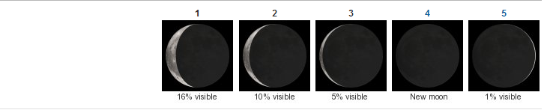
NOVEMBER
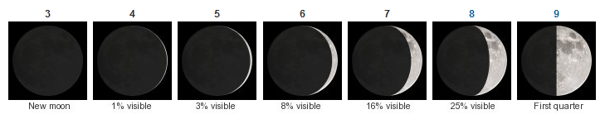 3th - 9th
DECEMBER
1st - 7th